
Year 4/5
Animals including Humans
Knowledge Oganiser

r
Teeth
The Digestive System
VOCABULARY
Oesophagus- a muscular tube which moves food from the mouth to the stomach.
Stomach- An organ where food is broken down with stomach acid.
Small intestine- nutrients are absorbed and used by the rest of the body
Large intestine- responsible for absorption of water. Faeces are formed.
Rectum- Faeces are stored before leaving the body through the anus.

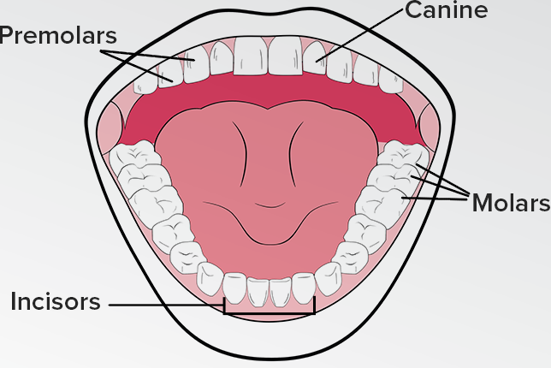
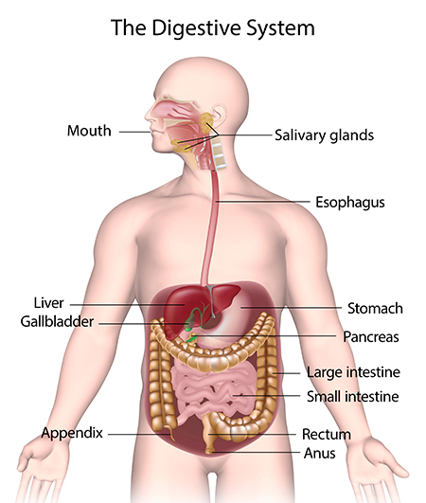
nnh
Rips and Tears
Holds and crushes

Grinds

Bites and cuts


Teeth Health
-Visit the dentist regularly.
-Brush teeth twice a day.
-Limit sugary food and drink.
-Use toothpaste with fluoride.









Year 4/5
Animals including Humans
Animal Teeth
Different animals have different teeth depending on what they eat.
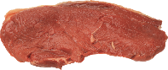
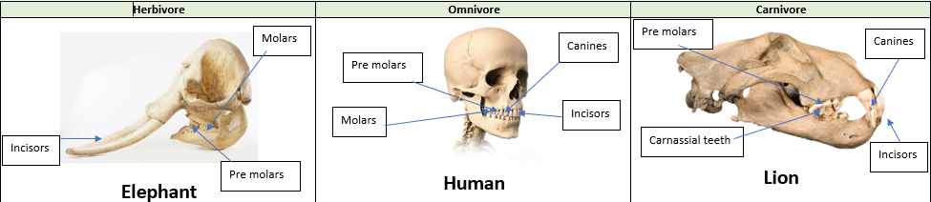



Eats plants and leaves
Eats plants, leaves and meat/other animals
Eats meat/other animals
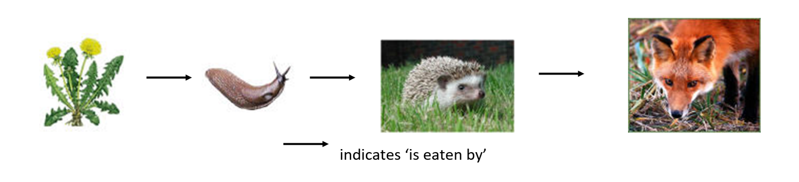



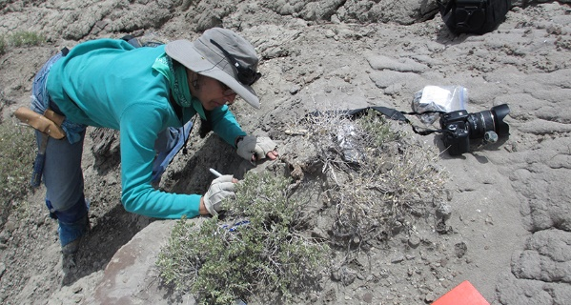
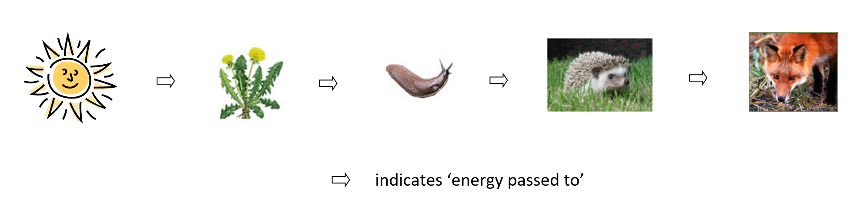
Tertiary consumer/ Predator.
Primary consumer/predator/prey
Primary consumer/prey
Producer
Food Chains
Scatologists study animal scat (faeces) to find out biological information about the animals they are studying.


