UKS2 PSHE - Knowledge Organiser – Relationships
Relationships | SUBSTANTIVE KNOWLEDGE:  I KNOW THAT:  - I know that I have my own qualities and self-esteem  - I know that friendships can change and can be managed or repaired  - I know that respect, trust, and empathy are important in relationships  - I know that people experience different feelings and types of relationships  - I know that I must stay safe when communicating, especially online  KS2 DISCIPLINARY KNOWLEDGE- I KNOW HOW TO:  - I know how to build and maintain friendships  - I know how to solve problems and manage conflict in relationships  - I know how to express my feelings and understand others’ feelings  - I know how to show respect, empathy, and kindness to others  - I know how to use technology safely and make responsible choices  Vocabulary  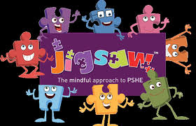  Friendship, compromise, empathy, trust, negotiate, loyalty, pressure, personal, body language, jealousy, emotions, risk, harm, safe, vulnerable, choice, identity
  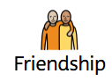 | A close relationship where people care about and support each other |  | 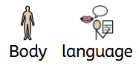 | How you use your body (like gestures or facial expressions) to communicate.
  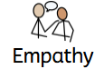 | Understanding how someone else feels. |  | 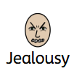 | Feeling upset because you want what someone else has.
  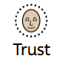 | Believing someone is honest and reliable. |  | 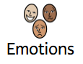 | Feelings like happiness, anger, or sadness.
  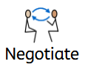 | To talk and try to reach an agreement. |  | 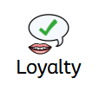 | Staying faithful and supportive to someone.
  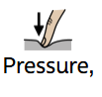 | Feeling pushed to do something. |  | 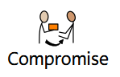 | When people agree by each giving up a little.
   | Something private or about you. |  | 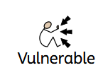 | Easily hurt or affected.
  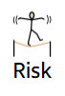 |  | The chance something bad could happen. | 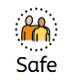 | Protected from danger.

