UKS2 History Knowledge Organiser – The Victorians
Industrial Revolution | 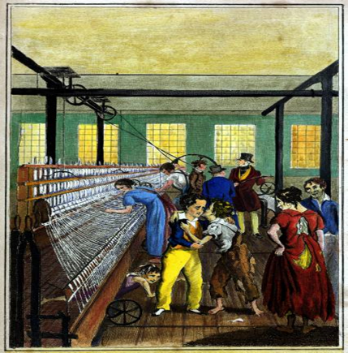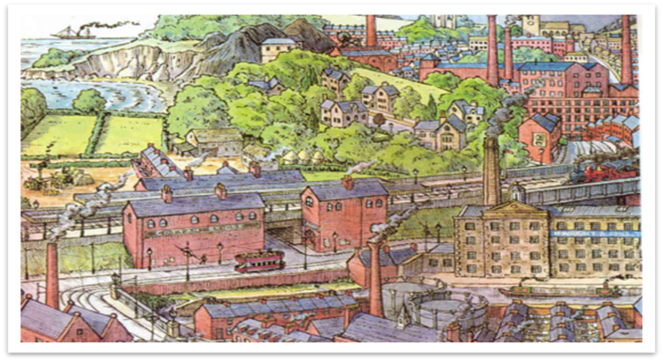  - I KNOW the main changes that took place in the Victorian period.  - I KNOW that the Industrial Revolution changed the lives of Victorian people, sometimes for the better.  - I KNOW the similarities and differences between town life and country life  - I KNOW the main changes in transport and technology during the Victorian era.  - I KNOW how the Victorians lived.  - I KNOW that the Victorian period can be interpreted differently depending on what aspect is given.
  Industry   | Making things people need or use, usually in large amounts. | Child labour   | Child labour means children having to work instead of going to school or playing.
  Factory  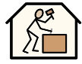 | A factory is a place where people work together using machines to make things, like clothes, toys, or tools. | Reform   | Reform means making changes to improve something and make it fairer or better.
  Causation   | Causation means that one thing causes another thing to happen. In history, it helps explain why something happened, not just what happened. | Revolution  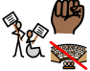 | A revolution is a big and important change that happens quite quickly.
  Invention  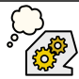 | An invention is something new that someone creates for the first time. It is made to help people do things more easily or solve a problem. | Chronology   | Chronology means putting events in the order that they happened, from earliest to latest.  It helps us understand what happened first, next, and last in history.
  Urban  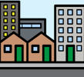 | Urban means related to a city or town. Urban areas usually have lots of people, buildings, shops, and roads. | Change   | Change means when something becomes different over time.
  Chimney Sweep  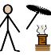 | A chimney sweep is a person whose job was to clean soot and dirt from chimneys so fires could burn safely. | Social history  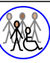 | Social history is the study of how ordinary people lived in the past.
  Enquiry  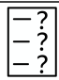 | Enquiry means asking questions to find out more information or learn about something. It is used when you want to understand why, how, or what happened. | Evidence  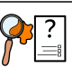 | Evidence means information or proof that helps show something is true.

