
Year 5
Properties of Materials
Knowledge Organiser


r
States of Matter
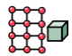

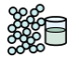
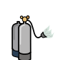

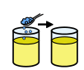
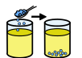
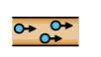

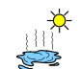
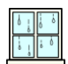
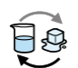

VOCABULARY
Solid- Firm shape or form that can be measured in length, width, and height not like a liquid of gas. Tightly packed molecules.
Liquid- no defined shape, takes the shape of its container. Particles free to move over each other.
Gas- easy to compress, expand to fill containers and occupy more space than liquids or solids.
transparent- You can see through it
Soluble- able to be dissolved
insoluble- cannot be dissolved.
Conductor- a substance that heat or electricity can pass along or through.
Filtering- a device used to remove dirt or other solids from liquids or gasses.
Evaporation- turn liquid into a gas; pass away in the form of vapour.
Condensation- small drops of water which form when water vapour or steam touches a cold surface.
Reversible- can be changed back e.g. ice to water.

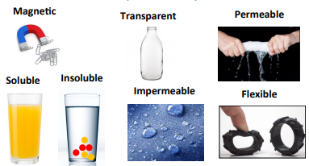
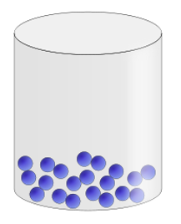
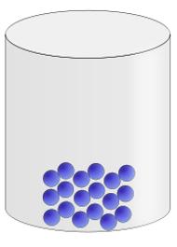
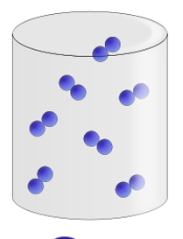
nnh
Grouping Materials based on properties.
Gas- particles move freely and expand to fill container.
Solid- firm shape with tightly packed molecules.
Liquid- no defined shape, takes the shape of its container.
Skills I am learning:
- I can compare and group together everyday materials based on their properties, including hardness, solubility, transparency, conductivity and response to magnets.
- I can identify that some materials will dissolve in liquid to form a solution and describe how to recover a substance from a solution.
- I can use knowledge of solid, liquid and gas to decide how mixtures might be separated including through filtering, sieving and evaporation.
- I can demonstrate that dissolving, mixing and changes of state are reversible changes.
- I can explain that some changes result in the formation of new materials and this kind of change is not usually reversible including changes associated with burning and the action of acid on bicarbonate of soda.
- I can give reasons based on evidence from comparative tests for the particular uses of everyday materials including metals, wood and plastic.
Reversible Changes
Irreversible Changes
Melting
Dissolving

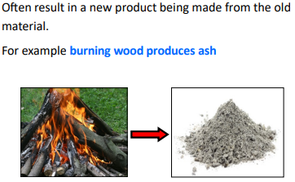
You can change it back to its original state.
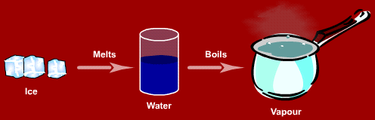
Changes state but does not mix.
Two substances becoming one solution.

