KS2 History Knowledge Organiser. The Tudors-NATIONAL CURRICULUM COVERAGE: KS2 – Study an aspect or theme in British history that extends pupils’ chronological knowledge beyond 1066, by exploring the changing power of the monarchs.
 | 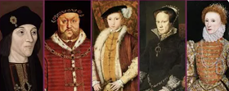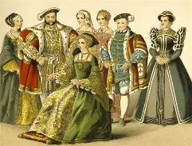  Substantive knowledge:  - I KNOW about Henry Vill and how he was portrayed  - I KNOW why Henry Vill  - broke from the Pope and Rome  - I KNOW that the rich and the poor had very different lives in Tudor times  - I KNOW why we have to be careful when using portraits of Elizabeth l when learning about the past.  - I KNOW why England defeated the Spanish Armada.  - I KNOW what live was like in Elizabethan England from their leisure activities  Disciplinary Knowledge  - I CAN make deductions about the past by analysing how and why different representations of the same person can vary (Historical Interpretations)  - I CAN sequence key events that led to the break with Rome (Chronological understanding).  - I CAN give reasons why England and Spain went to war (Cause and consequence)  Key Concepts:  Monarchy/ change/innovation/ people
  Substantive Vocabulary - the meaningful, content-heavy words central to understanding a topic.
  Monarch  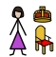 | The main ruler of a kingdom or empire, often from a royal family. | Causation | The link between cause and effect — showing how one thing leads to another.
  Heir  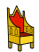 | The person who will inherit something (like money, land, or a title) in the future. | Catholic  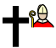 | Belonging to or relating to the Roman Catholic faith.
  Dynasty  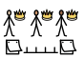 | A ruling family that maintains power across multiple generations. | Nobility   | The high-ranking social class below royalty, often with inherited titles and privileges
  Reign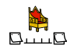 | A specific area distinguished by shared features or boundaries. | Gentry | Wealthy, landowning upper class below the nobility in rank.
  Privy Council   | A monarch’s private group of trusted advisers on important state matters. | Yeoman   | A free farmer who owned their own land, socially between labourers and the gentry.
  Reformation  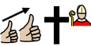 | The 16th-centuary movement that reformed the catholic church and led to the rise of protestant churches | Propaganda   | Information designed to persuade or manipulate public opinion, often by being biased or one-sided.
  Protestant   | A Christian who belongs to a church that separated from the Catholic Church during the Reformation. | Apprentice   | A learner who works with a skilled person to learn a trade or craft.
  Treason  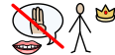 | The act of betraying  your country or ruler. | Armada  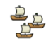 | A big group of warships gathered for battle or defence.
  Disciplinary Vocabulary - the specialised language and terms unique to a specific subject or field.
  Chronology   | Putting events in the  order they occurred. | Evidence   | Proof or information used to support an idea or fact.
  Social History   | The history of everyday  life and society. | Enquiry   | A careful investigation or search for information.

