Knowledge Organiser - Unit 1 Year 4
Musical Spotlight: Musical Structures | Name:
Social Question: How Does Music Bring Us Together? | Class:

Understanding Music Improvise Together
Tempo: | Moderato — at a moderate speed (112bpm) |  |  |  | Time signature: |  |  | 4 /4
Time signature: | 4 /4 — there are four crotchet beats in a bar |  |  |  | Key signature: |  |  | C major
Key signature: | C major — there are no sharps or flats in the key signature |  |  |  | Notes : |  |  | C, D, E, G, A ( C pentatonic)  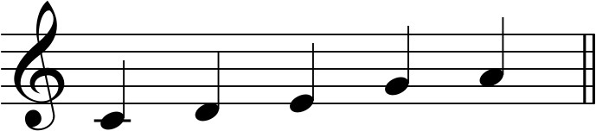
Rhythmic patterns using: | Minims, dotted crotchets, crotchets, quavers
SONG 1  Hoedown  Style: 20th and 21st Century Orchestral |  |  | SONG 2  I’m Always There  Style: Soul Ballad |  |  |  | SONG 3  Martin Luther King  Style: Contemporary R&B
Time signature: 4 /4 — there are four crotchet beats in a bar  Key signature: F major — there is one flat in the key signature  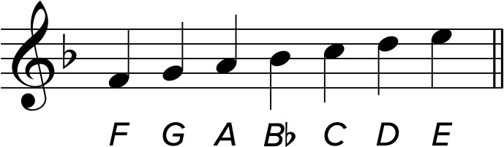  Circle the part you played:  Part 1: F, G, A, B♭, C  Part 2: F, G, A, B♭  Part 3: F, G, A, B♭, C  Part 4: F, G |  |  | Time signature: 4 /4 — there are four crotchet beats in a bar  Key signature: C major — there are no sharps or flats in the key signature  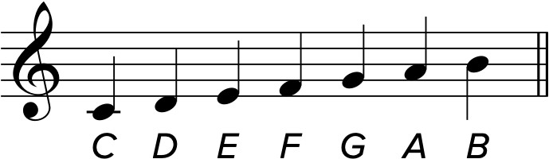  Discuss together what this song was about. Write down three words about the song: |  |  |  | Time signature: 4 /4 — there are four crotchet beats in a bar  Key signature: B♭ major — there are two flats in the key signature  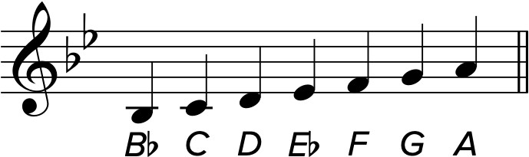  Discuss together what this song was about. Write down three words about the song:
© Copyright 2023 Charanga Ltd

