Mary Dean’s CE Primary School - Year: 1 and 2 - History Summer Term Cycle A 2nd half.

Bathing machine - A wooden cart with two doors which allowed bathers to change out of their clothes and into their bathing suits without having to be seen. | A penny lick-how you served ice-cream before cones were invented! | Vocabulary
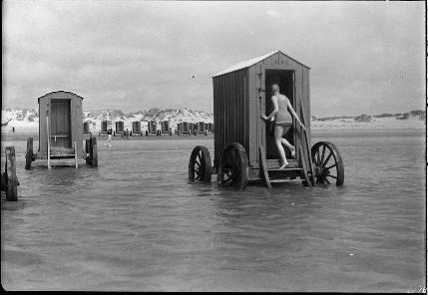 | 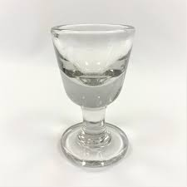
  Bathing machine | A wheeled hut drawn to the edge of the sea, used for changing in and bathing from.
  promenade | A path next to the beach where people go for a walk.
  Souvenir | Something that is kept as a reminder of a place or event.
  Amusement Arcade | An indoor area containing coin-operated game machines.
  Transport | A way of travelling from one place to another Seaside holidays in Victorian Times
  Carousel | A merry-go-round at a fair
  Steam Train | A train powered by steam
  Charabanc | An early form of bus used for trips
  Victorian era | A period of time between 1820-1914 when Queen Victoria reigned.
  Edwardian era | A period of time between 1901-1910 when Edward V11 and then 1910-1914 when George V reigned.
  Penny lick | A small glass for serving ice cream.
  Punch and Judy | A traditional puppet show in which main character Punch fights comically with his wife Judy.
Charabanc-An old fashioned bus which would have taken you to the seaside. | Punch and Judy show- entertainment for children on the beach.
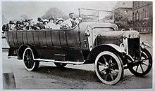 | 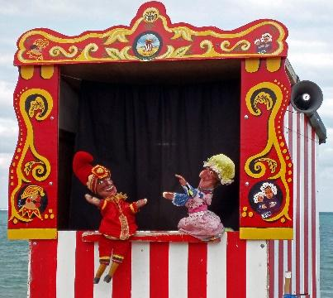
A steam train- As the Seaside grew in popularity the railways carried ever increasing numbers to the coastal seaside resorts.


