

LOVING AND CARING
CREATED
God
Christian and Jewish people believe that God created the world and the people in it. They believe that God created people in His Image. People can read this story in the book of Genesis which is the first book in the Christian Old Testament and the first Book of Moses for Jewish people.
This means that everybody on earth is different and unique, and we are all part of the worldwide community. Everyone who is religious or non-religious believes we should take care of the world and everyone in it.
In the Bible and the Torah there are many stories and teachings about how we should take care for planet, which is known as stewardship and how we should show love for each by looking after everyone. In the book of Psalms, Jewish people are told how much God loves and cares for them and in the Gospels, Christians are taught that God loves and cares for them as well.
People want to show how much they love and care for each other and they do this through helping other people by giving help like Mother Teresa did or by giving tzedakah. Many Jewish people believe the festival of Sukkot is about helping others just as God helped the Jewish people when they left Egypt.
Community: a group of people who have something in common
World: the planet and everything and everyone in it
Psalm: a sacred song or hymn, often used in Christian and Jewish worship
Stewardship: the act of looking after and caring for something
Love: a strong feeling of affection or attachment to someone or something
Genesis: the first book of Moses for Jewish people and the first book of the Old Testament for Christians.
Religious: believing in a religion
Non-religious: not believing in a religion.
Christian: anything that is part of, or someone who follows Christianity.
Jewish: anything that is part of, or someone who follows Judaism.
Important information
So how does it all work?
Wonderful words
How should we care for the world and for others, and why does it matter?
Year One
Knowledge
Organiser
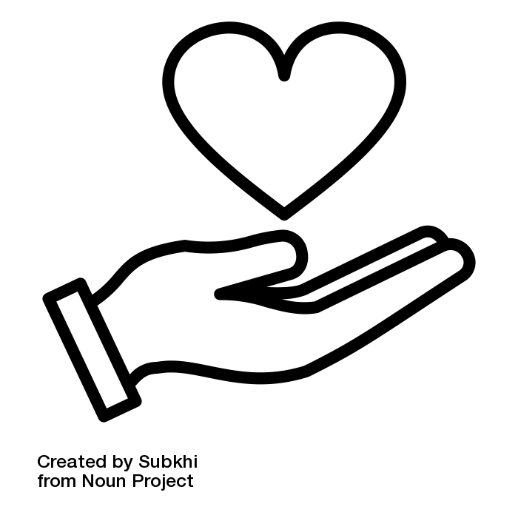
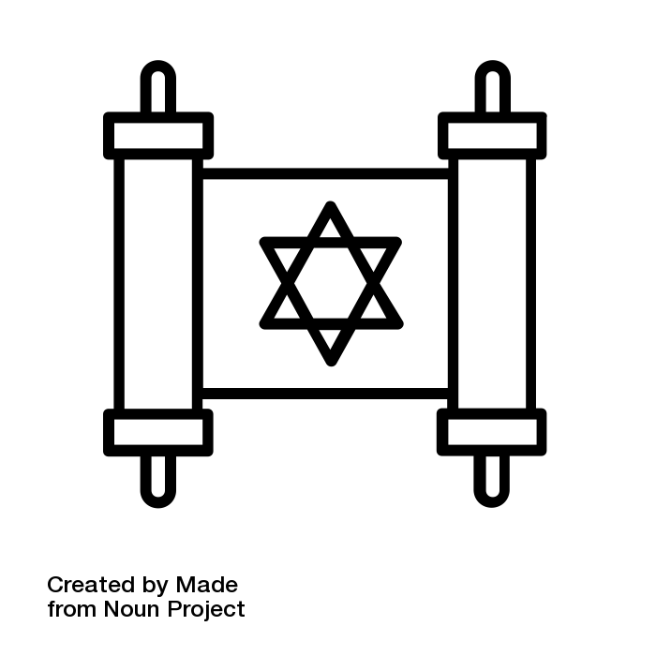

Year One – Knowledge Organiser
UNIT
12

